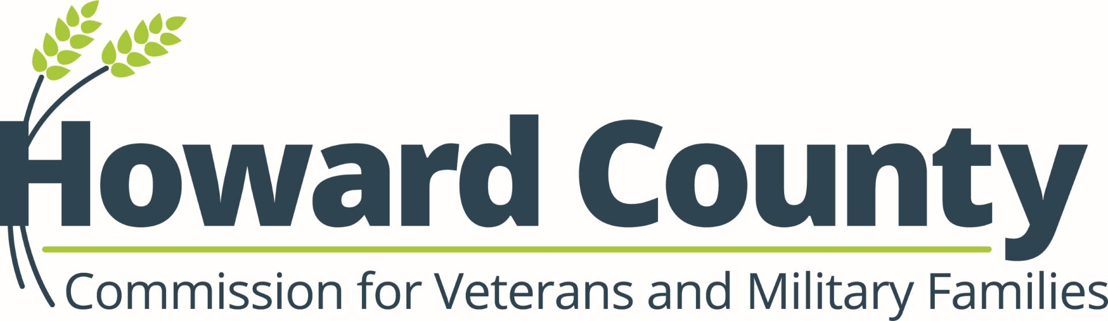

Meeting Information
Agency / Department | Howard County Office of Veterans and Military Families
Committee / Board | Howard County Commission for Veterans and Military Families
Meeting Title | Monthly Meeting
Date | March 5, 2026
Time | 7-8:30 p.m.
Location | DCRS 9830 Patuxent Woods Drive Columbia
Virtual Access (if applicable) | Microsoft Teams

Accessibility Statement
This meeting is accessible to individuals with disabilities. Reasonable accommodations such as sign language interpretation, assistive listening devices, or alternative formats are available upon request. Contact the meeting coordinator at least 48 hours before the meeting.

Call to Order
- Notes / Description: Quorum established at 7:05

Roll Call
- Present:
- Sean Keller, Chair
- Paul Rivers, Vice Chair
- Lisa Terry, Administrator
- Lorinzo Foxworth
- Candance Willett
- Sean Thomas
- Liesele Wood
- Ricky Snell
- Juan Valdez – Virtual
- Lisa Steptoe, Secretary

- Special Guests
- Sara Marlow, Director of Baltimore National Cemetery

Approval of Previous Meeting Minutes
- Approved February minutes

Public Comment
- Opening Comments by Commission Chair and Introduction of Special Guests
- 2026 Goals/Priorities/Ideas
- Lot of stress in our community at this time, especially with military action
- Serve as advocates of the veteran community, but we must take care of ourselves and look out for each other.
- Don’t get caught up in public debate, serve at the request of our county executive
- Recommended goal – focus on educational benefits

Presentations and Briefings
- Sara Marlow, Director, Baltimore National Cemetery Complex (802), US Department of Veterans Affairs
- 5 Sites in MD – Cheltenham, Eastern Shore, Rocky Gap, Crownsville and Garrison Forest
  - VA Burial Benefits. Pay Today. Honor Forever
    - 157 National Cemeteries
    - 124 VA grant-funded state and tribal Veteran Cemeteries
    - Manage over 9000 acres.
  - Eligibility
    - Any member of US Armed Forces who dies on active duty
    - Any veteran discharged under qualifying conditions
    - National Guard and Reservists with 20 yrs qualifying service.
  - Pre-Need Program – est. 2016
    - Pre-need burial eligibility determination program to assist anyone who would like to know if they are eligible for burial in a VA national cemetery.
    - Planning final resting place can eliminate unnecessary delays and reduce stress on family at difficult time.
  - Veterans’ Legacy Memorial Program – va.gov/remember
    - Every veteran has his/her own web-page on VLM
    - Keep alive the legacies of Veterans
  - Baltimore National Cemetery – 5501 Frederick Ave, Catonsville
    - Memorial Day
      - Carry the Load
      - Flag Placement – May 22 at 5
      - Ceremony – May 30th at 11
    - National Day of Service – Sept 12
      - Cleaning headstones, Fine Tune alignments, Benefits Info
    - Resources
      - National Cemetery Admin Website – https://www.cem.va.gov
      - Planning your Legacy Guide – https://benefits.va.gov/BENEFITS/docs/VASurivorsKit.pdf

Old Business
- Budget – committed most of the funds
- Howard County 250th Celebration (Turlington) – Sunday, 19 April from 11 a.m. - 4 p.m. at Belmont Manor

New Business
- 2026 VSO Flag Retirements at the VFW Ellicott City - 18 April, 18 July (followed by Patriotic Celebration & lunch) and 17 Oct, 11 a.m.
- Our Community Salutes Central MD HS Enlistee Ceremony – 21 April, 6:30 p.m. (doors open at 5:30 p.m.). Registration required.
- HoCo 250th at the Historic Belmont Manor Armed Forces Celebration - 19 April, 11 a.m – 4 p.m.
- Memorial Day Events - 23 May - VFW hosting; 24 May - American Legion 156 hosting at St. Johns Church and 25 May - Harriet Tubman Cultural Center
- Good Vibes and Voices Concert – 4 June from 6:30 - 8:30 p.m.
- Flag Day – 14 June
- 250th Anniversary of USA & Declaration of Independence – 4 July
- Ideas for VFW Day of Service in May

Public Hearing (if applicable)
- Notes / Description:

Reports
- Veterans Support Group (Rivers) -1st Monday of the month at 6 p.m. (virtual). Averaging 10 people at each meeting. After 6 years, steady participation from various counties.
- Mental Health Council (Rivers) – no update

Announcements
- Monument Dedication – 14 May 14 at 11 a.m. – Public Unveiling on Columbia Lakefront
- Draft of 2025 Annual Report shared
- Listed priorities for 2024/2025
- New Priorities to add for 2026
- Education Benefits for Veterans (workforce development, VA benefits – what they qualify for- GI Bill, VRE, Grants, VA Loan etc.) Ask an educational institution for updates.
- Homework – find speaker and educational resources and benefits.
- Fort Meade Resource Fair – 18 March, 10 a.m. – 3 p.m.
- Urgent Care Center Training
- Police Training for the Crisis Intervention Team to better respond to veterans
- Month of Military Child Events – Family Support Center, Bollman Bridge ES and Bellows Spring ES

Adjournment
- Notes / Description:

Official Meeting Minutes (Post‑Meeting Record)
Meeting Date | March 5,2026
Prepared By (Name, Title) | Lisa Steptoe
Minutes Approved On

