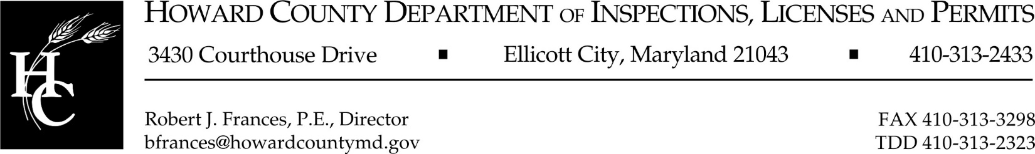

Date: January 28, 2025

To: All Solar Panel Installation Contractors

From: Donald L. Mock, P.E., Plan Review Chief

Subject: Solar Panel Locations for Smoke Ventilation Operations

Beginning January 28, 2025 all solar panel and photovoltaic installations must comply with this memo and Section R329 of the International Residential Code (IRC) regarding panel locations:

All solar arrays are required to meet the three (3) foot from the ridge fire setback OR indicate the total percent of roof coverage as well as the total roof area when using a reduced setback at the ridge of eighteen (18") on the cover sheet of the roof layout. Information as to whether the house is sprinklered or unsprinklered will also be required. The IRC Section R329.6.2 limits you to 33% roof coverage in un-sprinklered buildings and 66% of roof coverage in buildings protected by an NFPA 13D sprinkler system.

Pathways are not required when photovoltaic systems are installed on only one side of the roof structure.

Photovoltaic shingles (tiles) or BIVP Systems do not require any setbacks or access pathways when you can show compliance with IRC Section R329.6.4, otherwise you must provide pathways and setbacks at the ridge.

If you have any questions, I can be reached at 410-313-3948.

Copy: Robert J. Frances, P.E., Director DILP

Tom Huskins, Division Chief, Inspections and Enforcement

Derrick Harding, Supervisor Building Inspections,

T:\PlanReview\Policy & Procedures\Solar Panel Policy 2025.docx