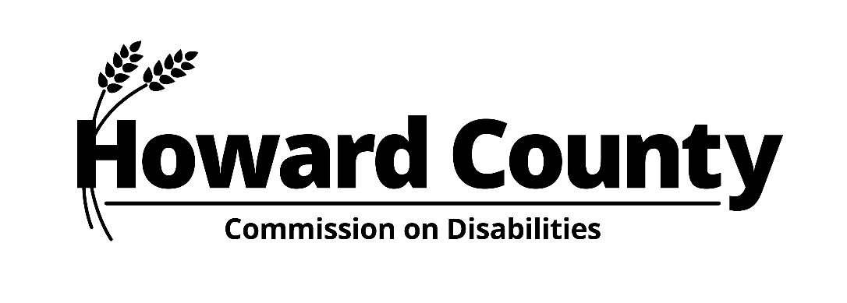
PUBLIC MEETING OF THE HOWARD COUNTY COMMISSION ON DISABILITIES
MONDAY, APRIL 24, 2023
6:30 TO 8:30 PM

LOCATION: DEPARTMENT OF COMMUNITY RESOURCES AND SERVICES
9830 PATUXENT WOODS DRIVE, ROOMS 346/347, COLUMBIA, MD 21046
CLICK HERE TO JOIN MEETING BY WEBEX

Agenda

- Call to Order, Roll Call
Jersey Haiku

- New Business
- Approval of Minutes of the February 27, 2023 Meeting
- Resolutions
- Annual Event or Signature Project
- Updates
- Access Committee
- Education Committee
- Maryland Alliance of Disability Commissions
- Opportunities to Get Involved

- Old Business
- Strategic Plan and Subcommittees

- Announcements

- Adjournment

To request accommodations for participation in Commission meetings, please call
410-313-6402 (voice/relay) or send email to CoD@howardcountymd.gov
at least five days (excluding Saturdays, Sundays, and holidays) prior to the meeting date.

