Ocftraining@howardcountymd.gov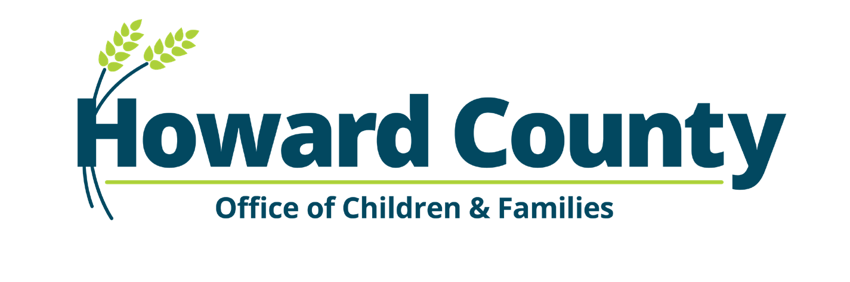

Workshops are held virtually through WebEx by the Department of Community Resources and Services' Office of Children and Families, or in person at 9830 Patuxent Woods Drive, Columbia, MD 21046.
*Online registration only* For questions, contact: Kristin Reel at kreel@howardcountymd.gov.

April

Healthy Meals for Infants and Toddlers In Person
Tues., April 11 / 6:30 PM - 8:30 PM / $5
E. Taylor / 2 HSN
A varied and nutritious diet and good eating habits are essential for infant & toddler healthy growth & development. Healthy eating habits are easy to establish early in a child’s life when the parents and caregivers have accurate knowledge of nutritional values. This workshop explores how to help build healthy eating habits in infants & toddlers.
CORE OF KNOWLEDGE KEY
Knowledge area(s), which identifies specific topics of interest you may need to achieve or maintain levels within the Maryland Child Care Credential program. The Core areas are abbreviated as:
CD: Child Development
COM: Community
HSN: Health, Safety and Nutrition
CUR: Curriculum
SN: Special Needs
PRO: Professionalism
Respecting All Family Structures Virtual
Thurs., April 13 / 6:30 PM - 8:30 PM / $5
S. Burke / 2 COM
Family structures have moves away from the traditional nuclear family. Identify different family structures that you may encounter in your program. Explore ways to make all children and their families welcome in your program.

Prioritizing Outdoor Play In Person
Tues., April 25 / 6:30 PM - 9:30 PM / $5
R. Gordon / 3 CUR
Prioritizing outdoor play has many benefits for children. We will identify these benefits, discuss challenges to outdoor learning, list strategies for implementing outdoor experiences and explore outdoor activities that span the domains in early childhood education.

Understanding Autism Today Virtual
Thurs., April 27 / 6:30 PM - 9:30 PM / $5
N. Pierre / 3 SN
Child care providers are key players in creating awareness of Autism and can offer support and guidance to families and children with Autism Spectrum Disorder. Participants will hear about recent developments in Autism research, learn to identify early warning signs of autism and find local support resources as well as learning effective teaching and documentation strategies for supporting children with Autism spectrum disorder.

Inclement Weather Cancellations
The Howard County Office of Children and Families follows the Howard Community College (HCC) inclement weather policy.

To receive immediate cancellation notifications, sign up for HCC Mobile Alertsat www.howardcc.edu
Updates are also available at 410-313-442
www.howardcountymd.gov/children

Recognizing & Responding to Child Abuse and Neglect
In Person
Thurs., April 27 / 6:30 PM - 8:30 PM / $5
S. Gold-Raynes / 2 CD
This workshop reviews the importance of recognizing challenging behaviors. Participants will learn what challenging behaviors look like, how to identify them, and what they can do to help. Participants will also learn how to create written observations of behaviors to identify patterns and implement strategies to prevent challenging behaviors from occurring.

