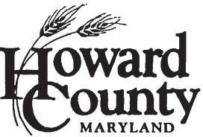

MULTIMODAL TRANSPORTATION BOARD
February 28, 2023-6:00pm Virtual via Webex
****************************************************************************AGENDA
Regular monthly meeting
- Approval of Agenda for Meeting – Chairperson Schoen

- Approval of January 24, 2023, Meeting Minutes

- Public Comment – General Topics (Participants who have signed up in advance will have 3 minutes each to address the MTB)

- Office of Transportation Updates, Bruce Gartner …..........................................(5 mins)
  - Active Transportation Open House at Elkridge Library on 2-21-23
  - HoCo by Design – Update on Council Consideration

- Scooter Report-CE EScooter/bikeshare next steps, Chris Eatough...............(25 mins)

- State Transportation Priority Letter, David Cookson....................................(30 mins)

- Development Review –Patrick Smith …............................................................(20 mins)

- Future Meeting Items
  - County Capital Improvement Program (CIP) Outlook (March)
  - Howard County Transit Development Plan Update (March)
  - Complete Streets Implementation Update (April)
  - State legislative update (April)
  - County Climate Action Plan Transportation Items (April)
  - Update on Baltimore Metropolitan Council/BRTB programs and projects (April – May)
  - Annual Election of Chair and Vice Chair (May)
  - US 1 Updates (May – June 2023)
  - Development Reports (Ongoing)

- Adjournment

10) Next Meeting – March 28, 2023, at 6:00 pm
Total time estimate: 90 minutes

