News from the Trails  2022 | 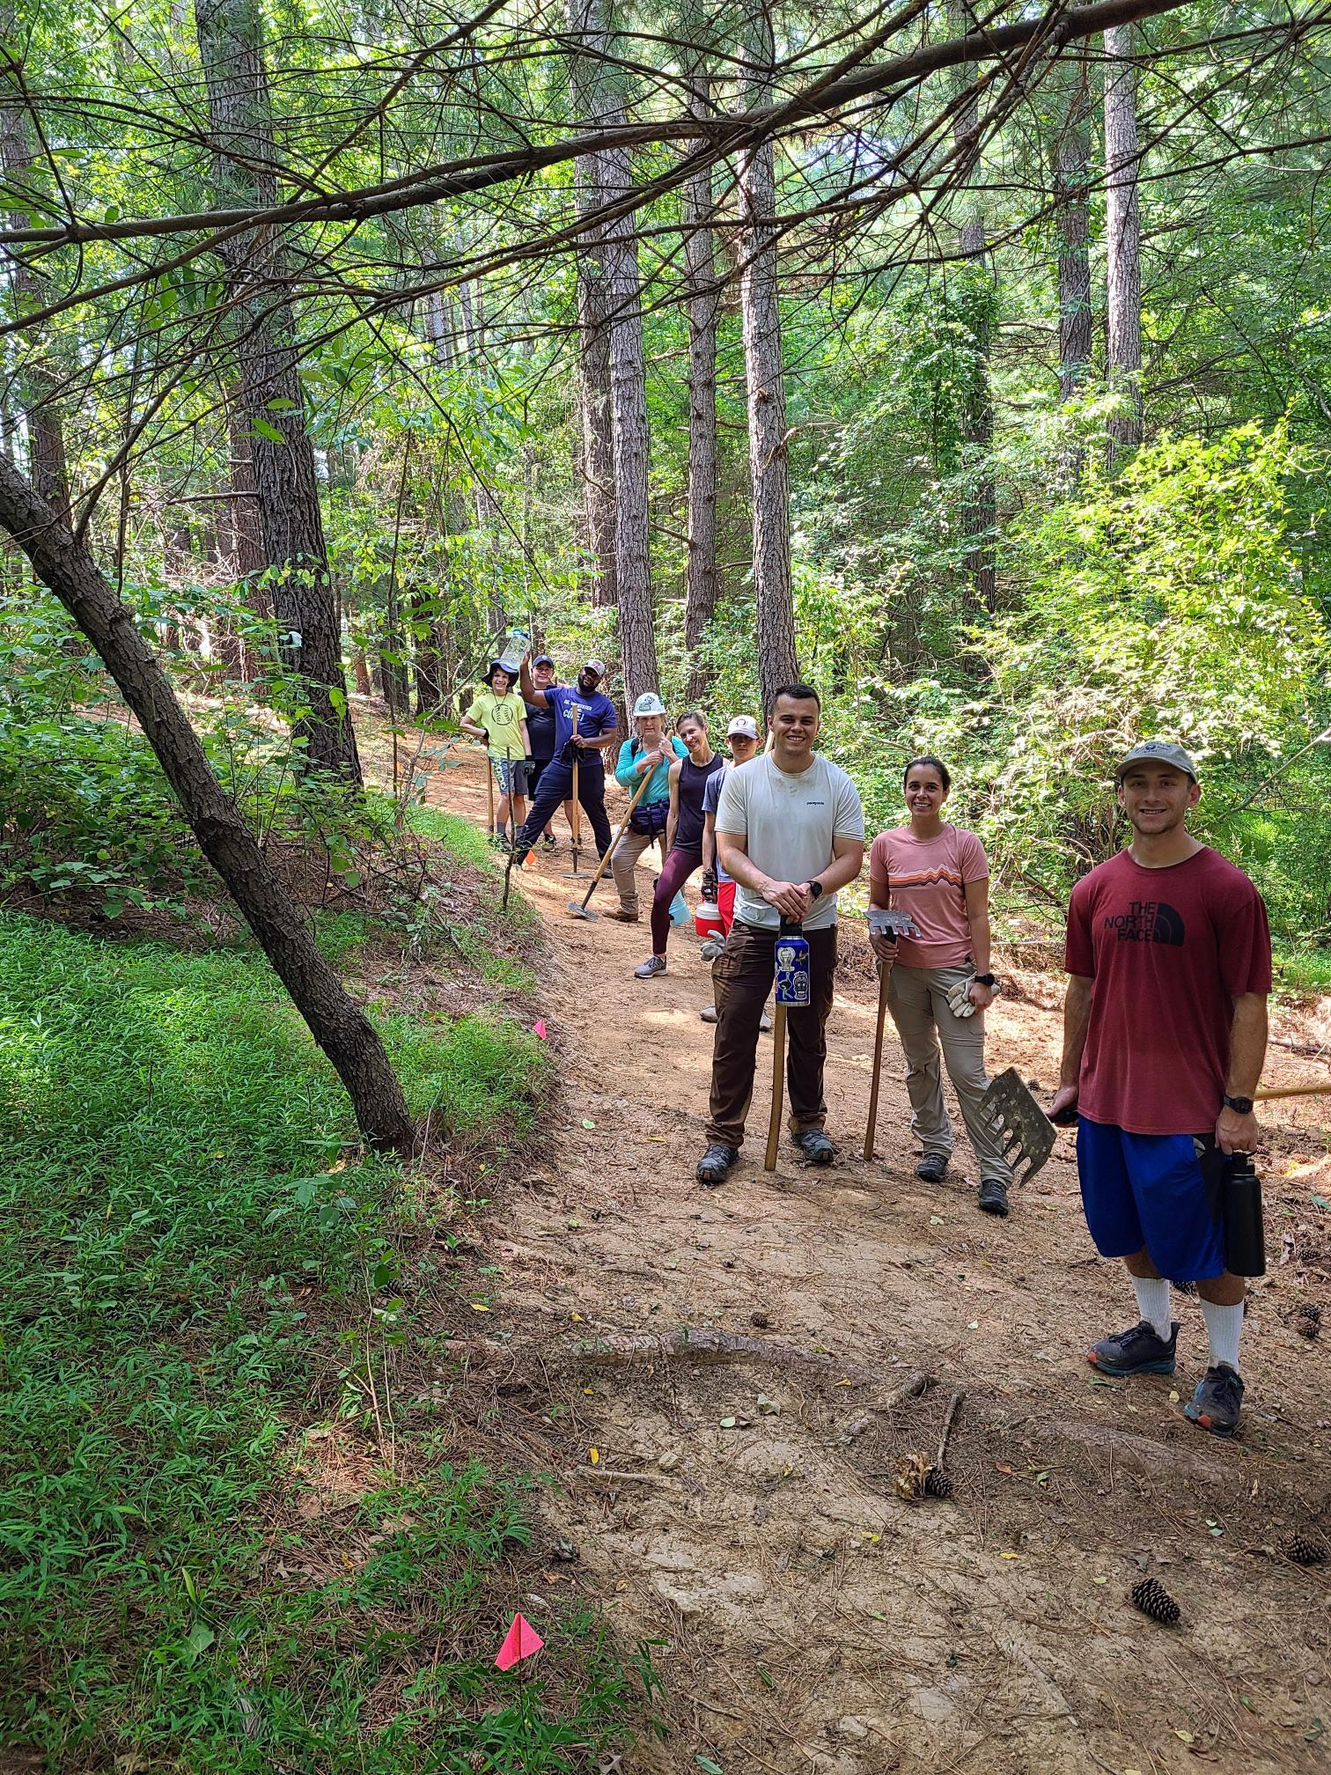  Volunteer Workday at David Force Park  Trail Care Crew
Inside

This
Issue
PG. 2
VOLUNTEERS
Discover what our volunteers have accomplished
PG. 3
TRAININGS/ EVENTS
Trainings & Events that occurred in 2022
PG. 4
NEW INITIATIVES
Everything we are working on to better our trails
This year has been full of hard work and communication. Trail projects occurred at Rockburn, Savage, Schooley Mill, Gorman NRA, Western Regional, Robinson Nature Center & David Force.
Many thanks to volunteers and staff who took the time to help out on the trails this year!

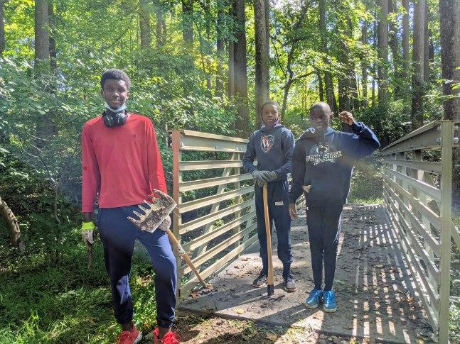

Volunteers
We wouldn’t be able to complete all the trail work this year without the help of our volunteers. See below for all that was accomplished in 2022!

Volunteering by the numbers
Volunteers at David Force Park
David Force Park | Savage Park | Timberland Circle Open Space | MPEA
58 volunteers completed 415 hours and built 2,485 feet of trail | 31 volunteers completed 128 hours and built 1,450 feet of trail | 2 volunteers completed 189 hours and maintained 11,263 feet of trail | 4 volunteers completed 440 hours and maintained 26,677 feet of trail
Corridor clearing at Savage
There were 8 scheduled volunteer workdays at David Force with an additional 3 corporate groups. At Savage Park, there were 3 workdays with Girl Scouts for a Gold Award Project.

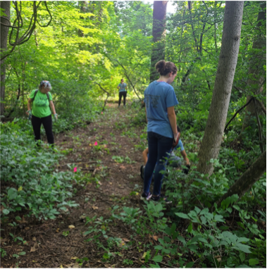

“Service to others is the rent you pay for your room here on Earth”
-Muhammad Ali

Events  - 2/6: Little Patuxent River Run at PBT with 500 attendees  - 2/12: Mid-MD Ultra 50k & relay at RBP with 400 attendees  - 4/9 & 4/16: Walk-a-thon at CEN with over 300 attendees  - 4/9: Attended GreenFest and got a list of potential volunteers.  - 8/7: Lustgarden Walk at CEN with 300 attendees  - 8/15: Columbia Triathlon at CEN with 1,500 attendees  - 8/28: Mid-MD Triathlon at CEN with over 1,500 attendees  - 9/11: Police Pace 5k at CEN with 1,200 attendees  - 9/24: Alzheimer’s Assoc. Walk at CEN with 1,000 attendees.  - 10/3: Haviland Mill Park Grand Opening. The first universally accessible natural surface trail in the County.  - 10/15: Pet Parade at CEN with 500 attendees  - 11/14: Cyclocross at RBP with 400 attendees  - 11/19: HoCo Autism Society Walk at CEN with 500 attendees  - 12/10: Big Foot Race at RBP with 500 attendees  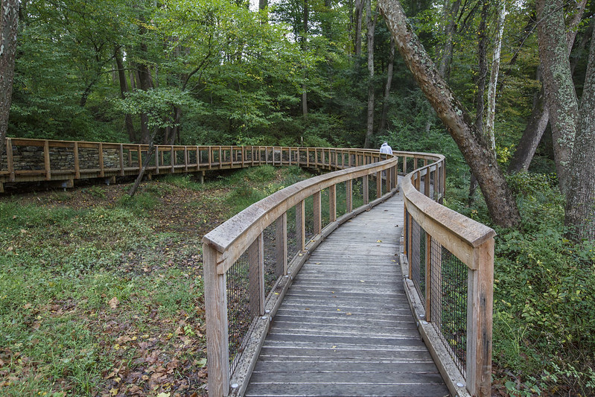  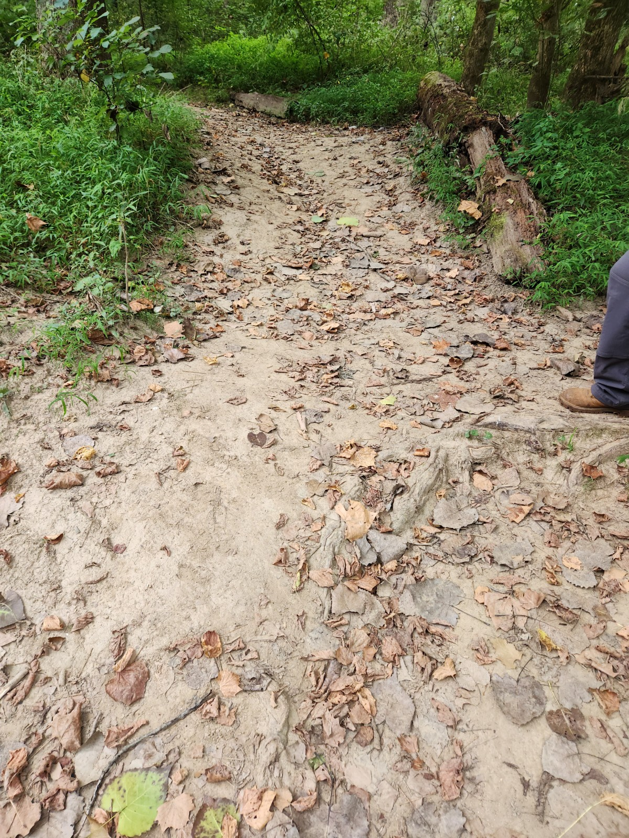  New Initiatives  - Created Trail Work Plans for  Robinson Nature Center &  Timberland Circle Open Space  - Completed and received  wayfinding signs for Western Regional  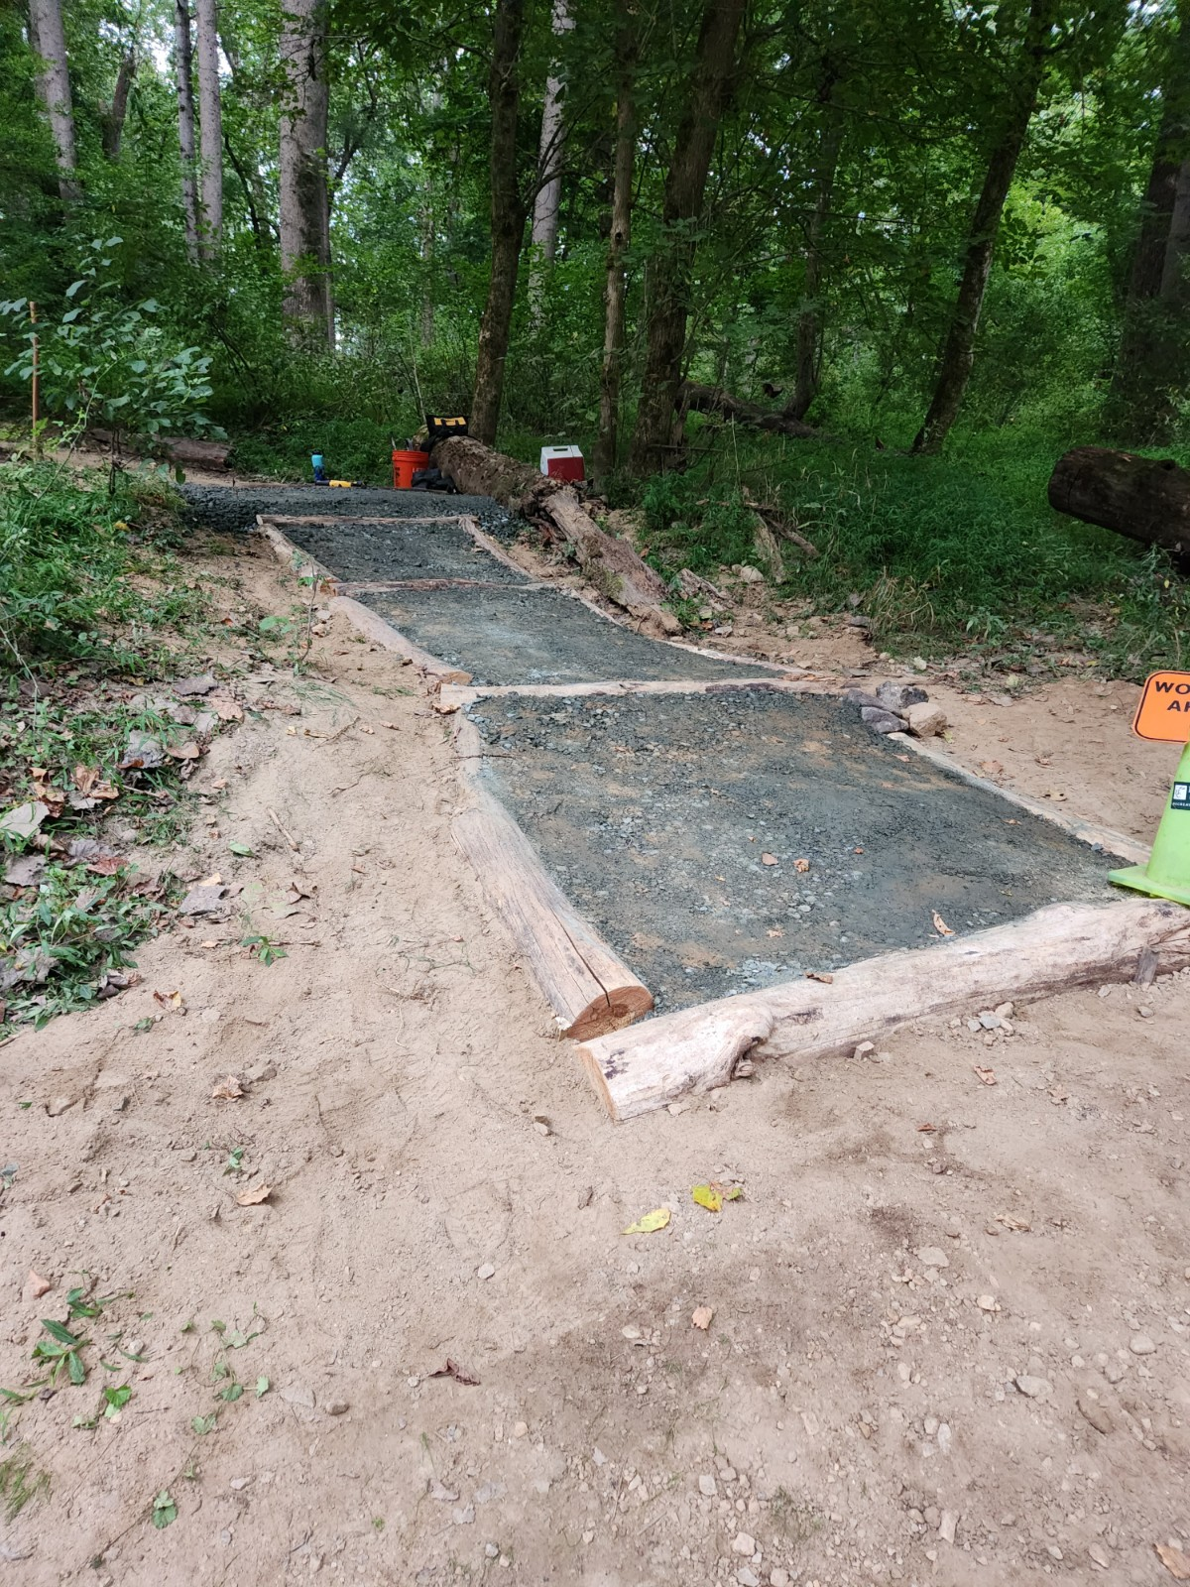  to be installed in early 2023  - Updating bridge layers in MapInfo and receiving  Above: Before pic at RNC where trail was unsustainable down to water  Left: Fixed trail with locust logs and aggregate steps  new 911 bridge signs for DFP & CEN  - Mapped 6 miles of user defined trails  at Gorman NRA  - Continuing work on MapInfo Trail Layers  - Work is almost completed at Rockburn Segment 11C, the old trail was closed, and 200 trees were planted.  - Completed work on stairs down to the water at Robinson Nature Center  - Ordered and received new GPS Units with  iPads for NHRD to work on field data more  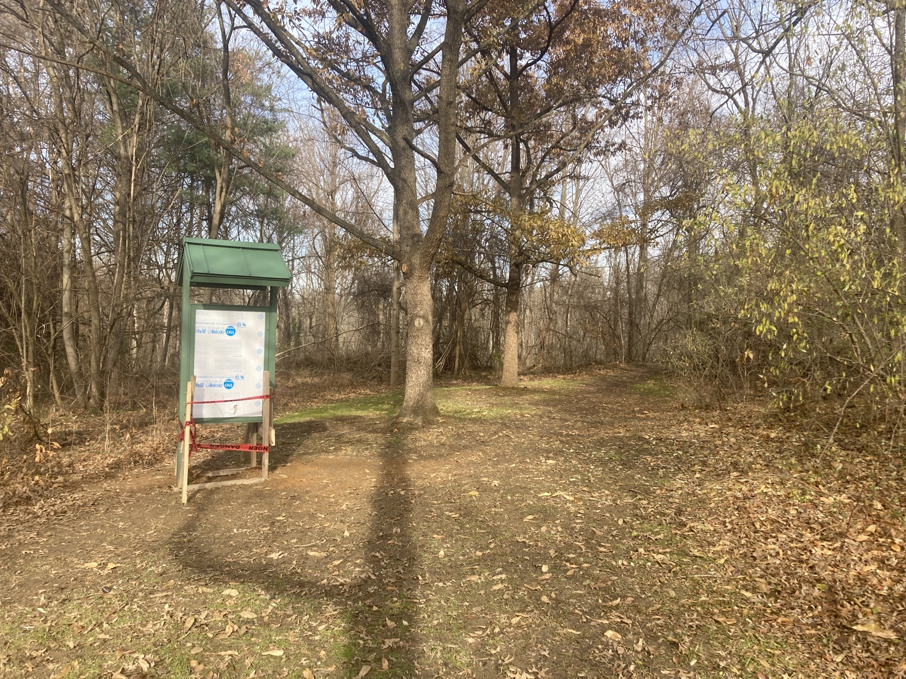  efficiently  - Completed Schooley Mill Park Trail Assessment and  working on generating a work plan for 2023  - Trail improvement projects identified in 2015 trail assessment to start at Savage Mill Trail in 2023  - David Force Park received a lot of help this year, 4 new bridges are ordered and will be installed along with a new front entrance kiosk! -Special Thank You to Park Construction Crew for assisting.  Right: Newly installed kiosk at David Force Park | trainings & events  Trainings  - Several American Trails Webinars were held throughout the year. You can still find them here:  https://www.americantrails.org/training/webinars  - 1/12: Conducted Trail Training for Zone 3 staff at Schooley Mill Park  - 4/29-4/30: Trail Seminar on “Building Trails in Wet & Wetland Areas”  - 8/30-9/1: Trail Rigging Workshop to learn how to move large rocks and create new trail features  - 9/12-9/16: Wetland Delineation course to be sure when new trails are built, we are not disturbing the natural environment  - Over the year, trained 86 volunteers with on-site training for volunteer workdays.  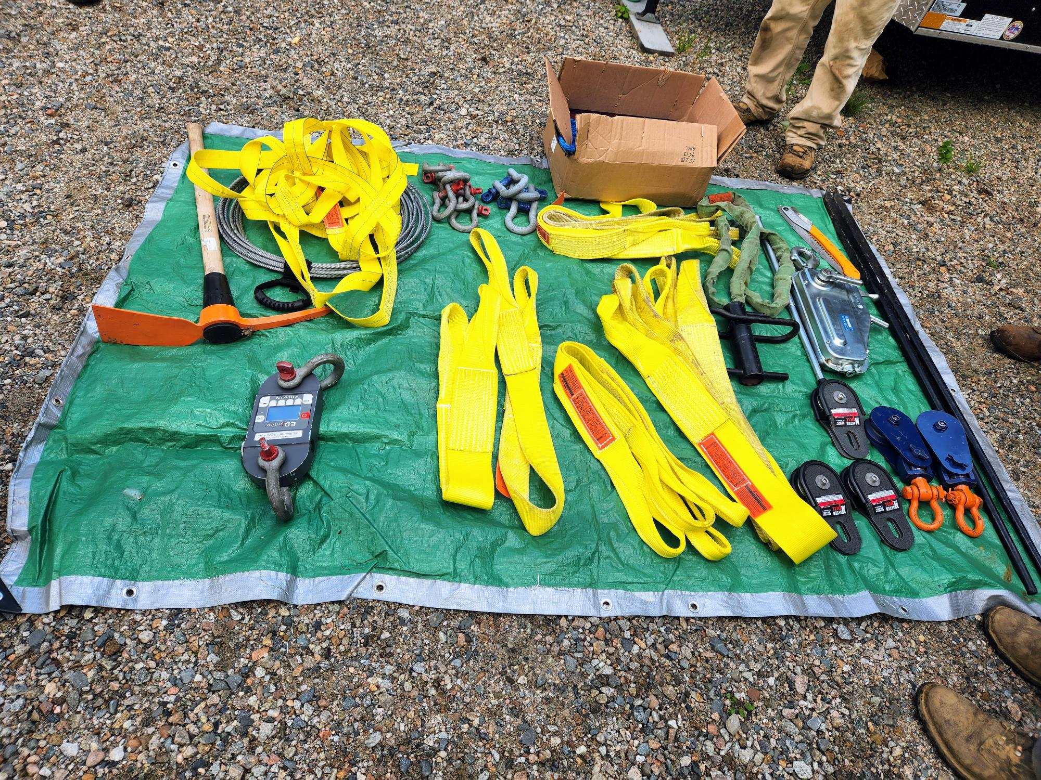  Above: Picture of rigging equipment used in training  Left: Haviland Mill Park trail

