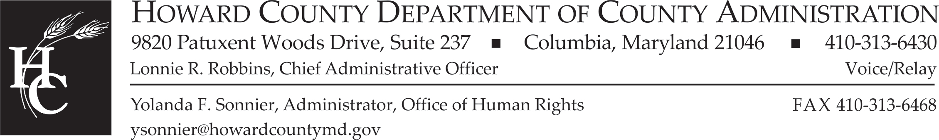

LA ALIANZA LATINA WORKGROUP
AGENDA
Tuesday, August 10, 2021

Event address for attendees: | https://howardcountymd.webex.com/howardcountymd/onstage/g.php?MTID=e1e453f987ed825b0be1eb36a500da426
Event address for panelists: | https://howardcountymd.webex.com/howardcountymd/onstage/g.php?MTID=eb53836a186934f554be6cb0d82883a22

- Welcome and General Updates from Co-Chairs

- Approval of May 11, 2021 Minutes

- Presentations:
Serology: APL
    - Sara Gravelyn & Teresa Colella
Equity Audit & Community Focus Video Presentation
    - Dr. Denise Boston –Equity & Restorative Practices Manager

- Committee Reports/Updates:
  - Education Committee – Sandy Cos
  - Health – Dr. Yvette Oquendo-Berruz
  - Economic Equity and Empowerment – Maria Vargas

- Hispanic Heritage Month
  - Outline/Overview
  - Confirming/Solidifying Dates & Timeline
  - Tasks/Roles/Responsibilities

- Questions/Workgroup Member Announcements

- Adjournment

NEXT MEETINGS: November 9, 2022 and February 8, 2022 at 6pm

