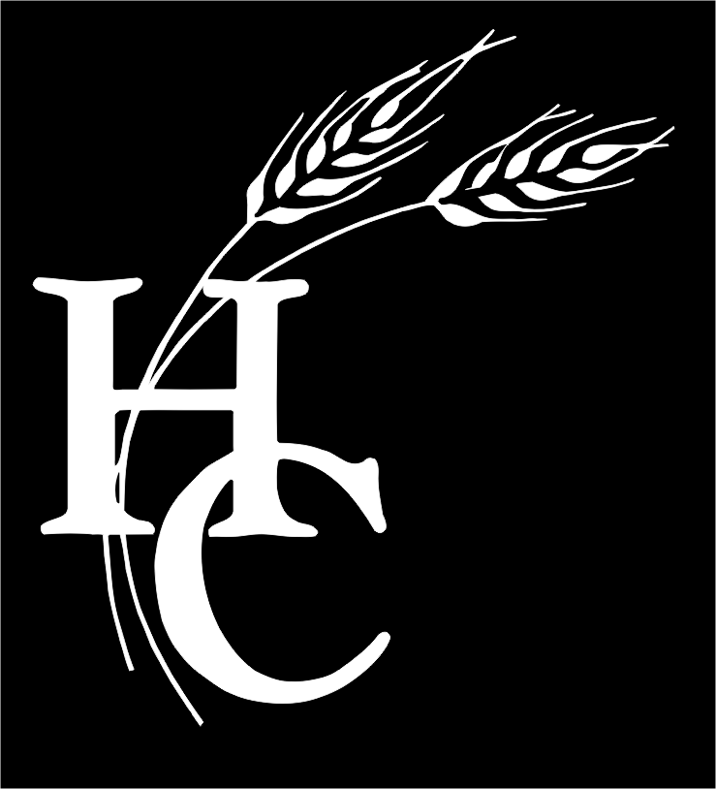
EQUAL BUSINESS OPPORTUNITY COMMISSION
MEETING AGENDA
May 05, 2016 @ 9:00 AM

Office of Purchasing Conference Room
6751 Columbia Gateway Dr., Ste. 501, Columbia, MD 21046

- Greetings & Welcome
- Approval of Minutes of February 02, 2016
- Vote on EBOC applications
February 02, 2016 through May 05, 2016
- Purchasing Reports
- Member Comments
- Adjourn Meeting

Howard County EBOC

Chair
Nathaniel Alston, Jr.

Vice Chair
Nancy Briguglio

Ex-Officio
Lonnie Robbins

Executive Secretary
Darla Herbold

Legal Counsel
Constance Tucker

EBO Coordinator
Mahesh Sabnani

Members
Roger Barnes
Barry Curtis
Steven Joss
Margaret Kim
Jason Peay
Shahan Rizvi
Tajuddin Sabree

purchasing@howardcountymd.gov FAX 410-313-6388
www.howardcountymd.gov/purchasing TDD 410-313-2323

Howard County Equal Business Opportunity Commission
6751 Columbia Gateway Drive Suite 501 ▪ Columbia, Maryland 21046 ▪ 410-313-6370

NEXT EBOC MEETING: June 07, 2016 - 9:00 AM TO 11:00 AM

Howard County Equal Business Opportunity Commission (EBOC) Meetings are open to the public. If you have specific questions or are planning to attend, please contact the Office of Purchasing at 410-313-6370. Please call ahead to confirm in case of last minute changes or cancellations. Thank you!

